**Azure ML Studio Assignment**

**Name: Aayush Tomar**

**Shell Email:** [**Aayush.Tomar@shell.com**](mailto:Aayush.Tomar@shell.com)

**Data onto Azure Blob Storage**

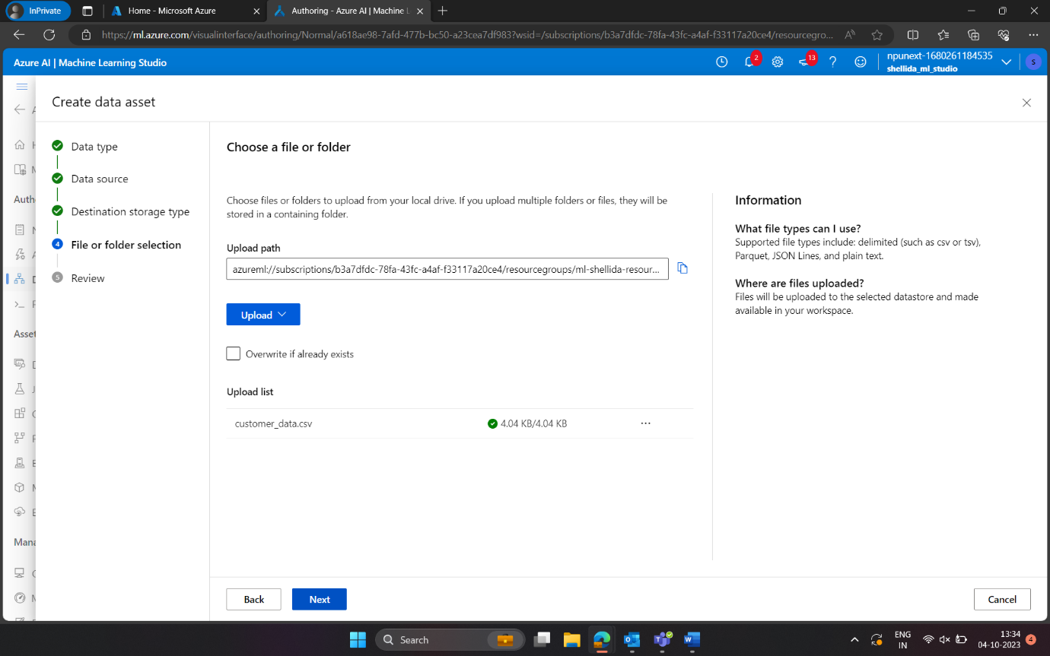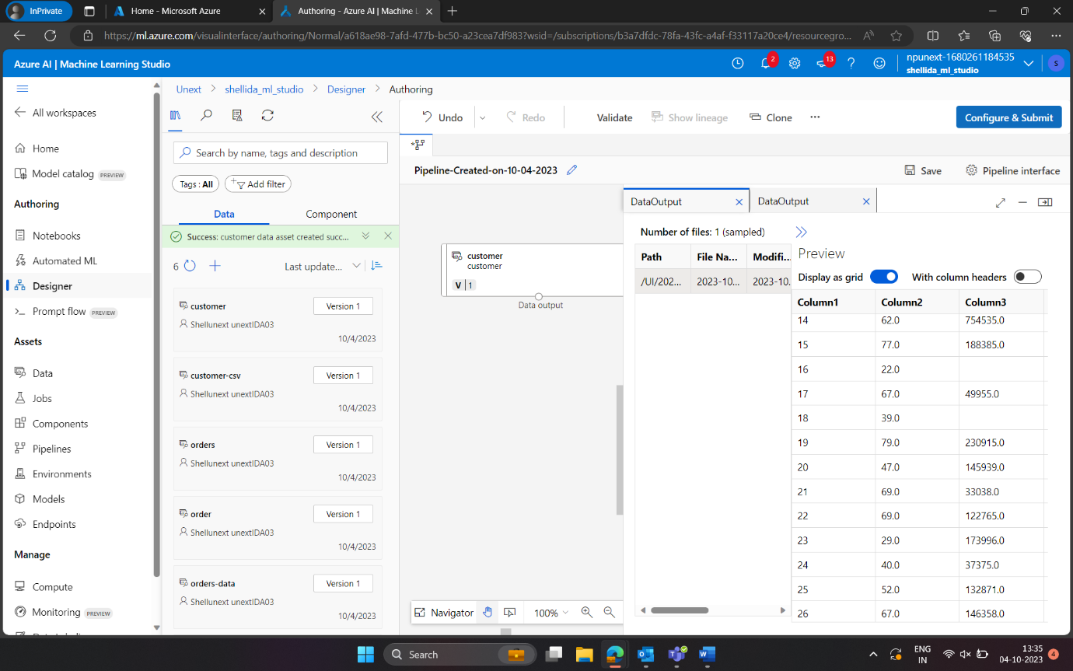

**Preprocessing Data**

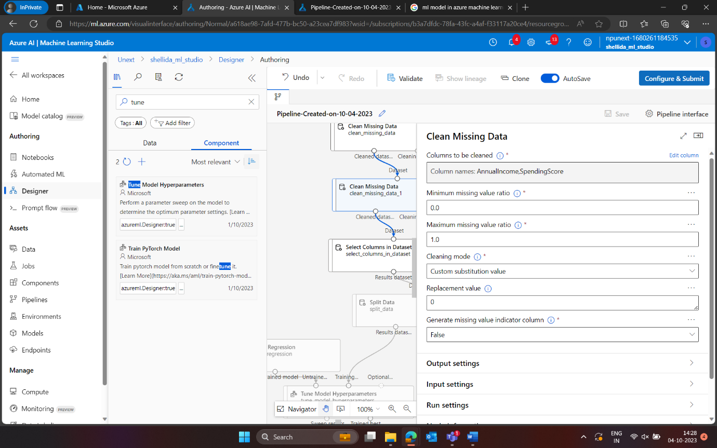

**Model Development**

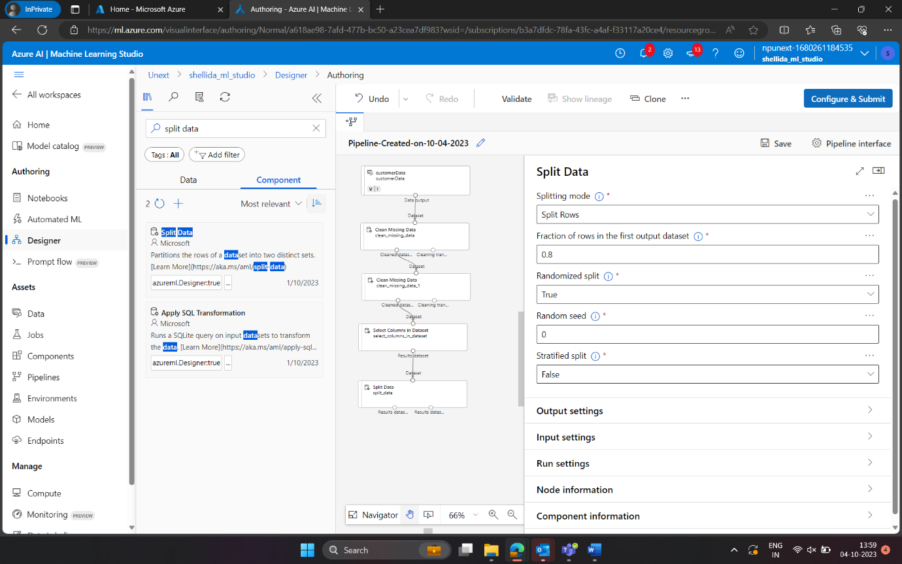

**Tune Hyperparameters**

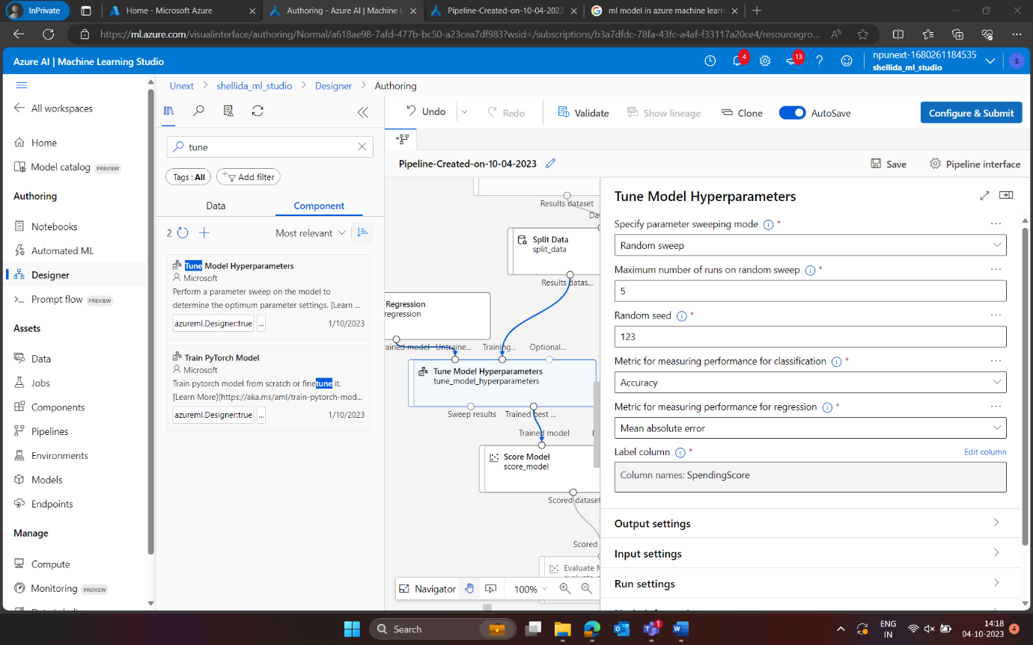

**Q1.** The key steps involved in preparing the dataset for model training are:

* Data Cleaning: Removing null values, cleaning data types, assigning proper schema.
* Feature Extraction: Reducing the dimensionality by selecting suitable columns for prediction.
* Feature Engineering: Creating new columns from existing columns to for more accurate prediction.

**Q2.** Splitting the dataset into training and testing helps validate the machine learning model. If the data is not split, the model’s accuracy can’t be determined on random data. Splitting the dataset can help recognize the overfitting or underfitting nature of the ML Model used, which helps tune the model for real world scenarios.

**Q3.** For the given dataset, purchasing behaviour can be predicted by predicting the SpendingScore of the customer. SpendingScore being a numeric value, a regression model would work best for the dataset provided.

**Q4.** Hyperparameter tuning refers to tuning the parameters available with any machine learning model for better accuracy in real world scenarios. This technique helps reduce the underfitting or overfitting nature of a machine learning model. This benefits us by providing better accuracy for unforeseen data, for which the ML model is intended.